|  |
| --- |
| https://codecanyon.net/user/linkbirdtech | LinkBird Technologies |



|  |  |
| --- | --- |
| LinkBird Technologies | How to create a MySQL database? |

**Download and install XAMPP, if you don't have the version.**

**Step -1**

Please download & install XAMPP to manage MySql database

If you don't have a MySQL Database, you can download it for free here:

<https://www.apachefriends.org/download.html>

**Step-2**

MySQL is the de-facto standard database system for web sites with HUGE volumes of both data and end-users. Another great thing about MySQL is that it can be scaled down to support embedded database applications.

* After installing XAMPP, Open XAMPP Control Panel
* Start Apache & MySQL service module

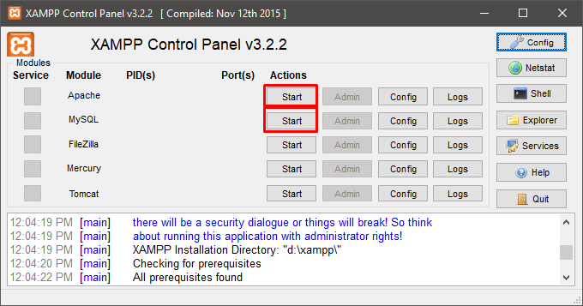

After successfully running Apache & MySQL service module, green signal will show the service.

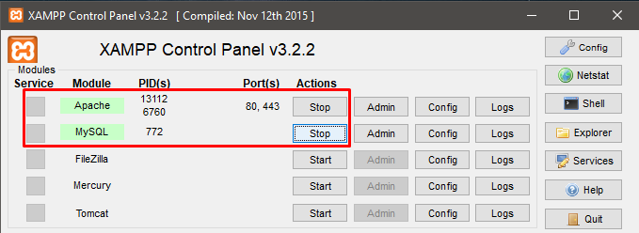

**Step-3**

* Open any web browser from your computer
* Go to your browser's address bar type <http://localhost/> or <http://127.0.0.1>
* After a while, the XAMPP Apache page will be opened.
* Click MySQL from this page.
* Or enter this link directly from the browser. <http://127.0.0.1/phpmyadmin/>

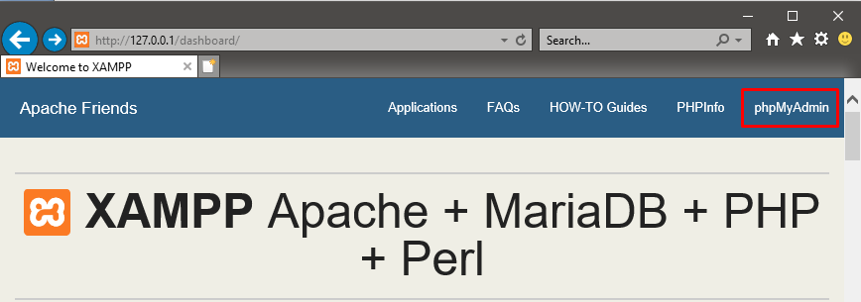

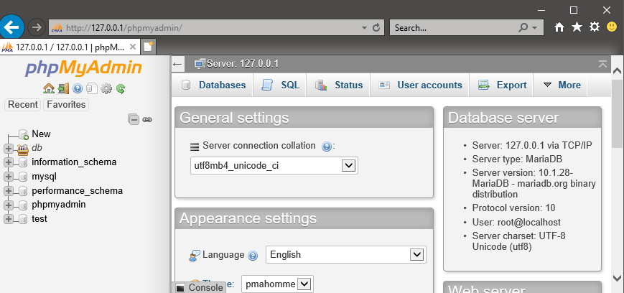

Click on database tab

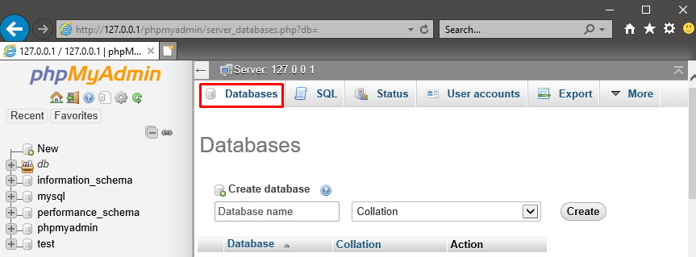

Enter database name **dbOrion** and select collection type **utf8_bin** and click con create button.

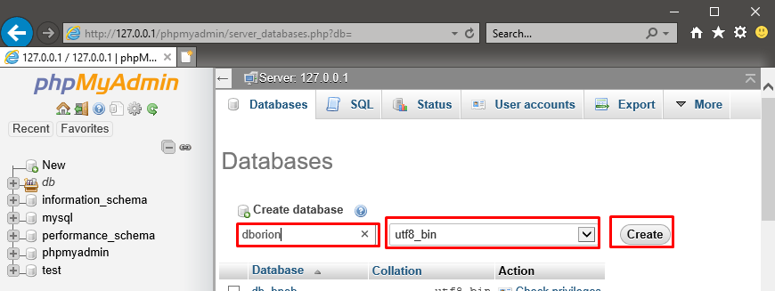

After successfully creating database click **dborion** left side of the menu and click on **Import** Tab.

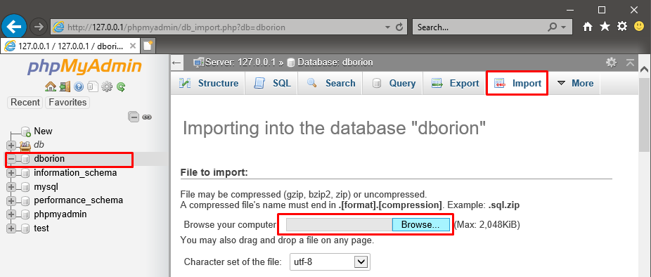

Click on browse button Browse MySQL script from your computer. We provided **mysql_script_dborion.sql** files in the SQL Script Database folder. And Click **Go** button

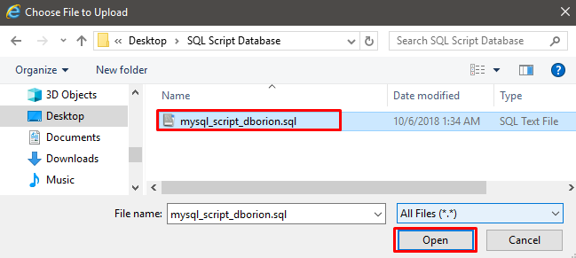

After successfully importing **mysql_script_dborion.sql** , Import has been successfully finished message will be shown.

Left side of the database list , expand **dborion**. You can see all datatable in this database.

